Name | Low Taek Jho ( China Name : Liu Tezuo )
Extra Info | Low was the youngest of three children
X | https://x.com/jho_low
Birthdate | 4 November 1981
Hometown | George Town, Penang
Grandfather | Tan Sri Dato’ Low Meng Tak
Linkedin | https://linkedin.com/in/lowtaekjho  https://www.linkedin.com/in/jholow/  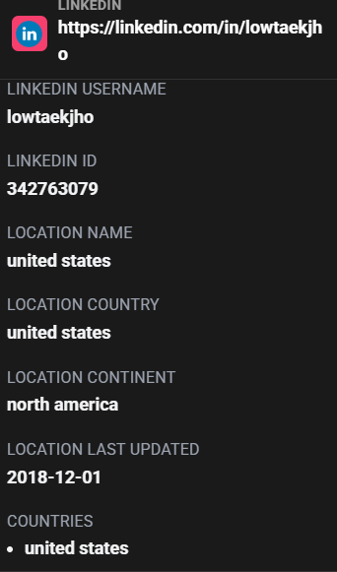
Company | Jinwei Financial Co. Ltd / address: 19/F, 50 Connaught Road Central, Hong Kong
University | University of Pennsylvania
High School | Chung Ling High School  The International School of Penang  Harrow School
Instagram | https://www.instagram.com/jholowjynwel/?hl=en
New Pasport | 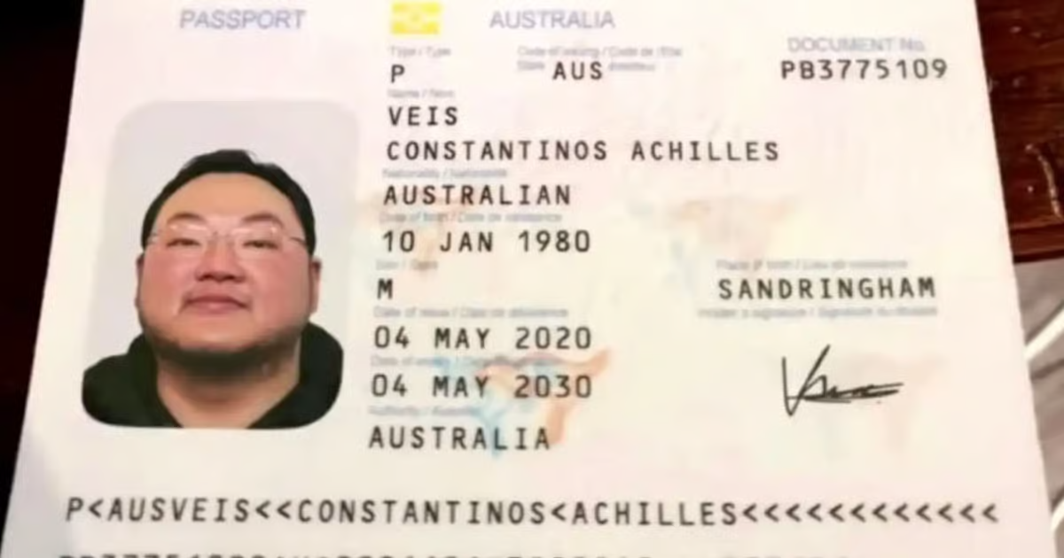  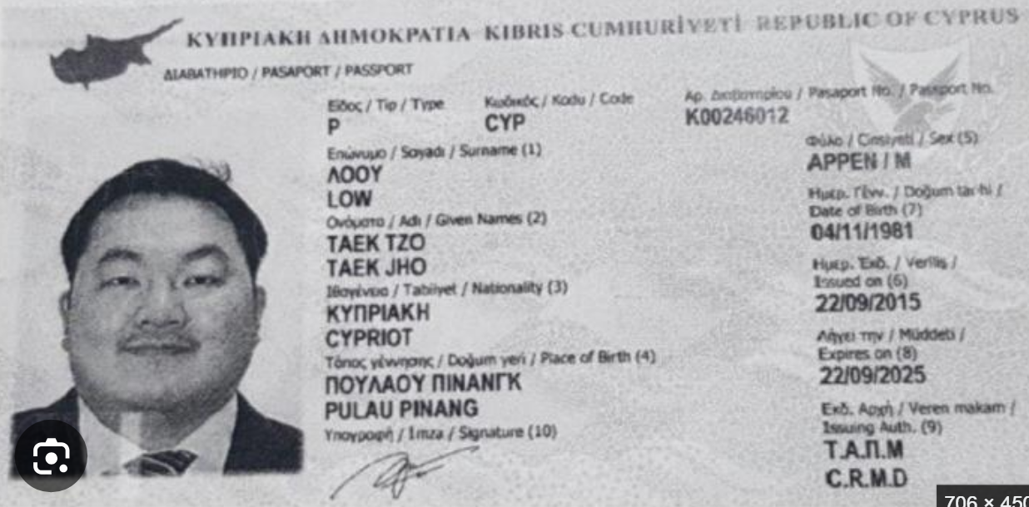
New name: | 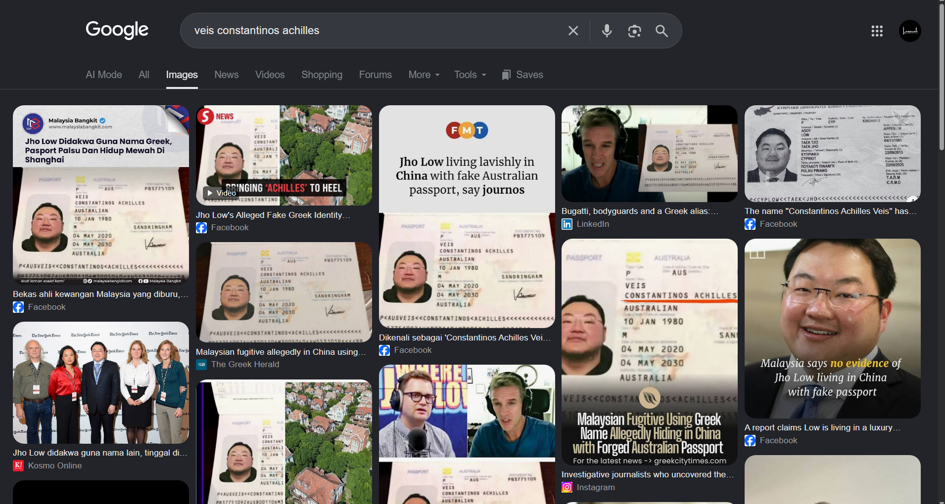
Location Profiling | 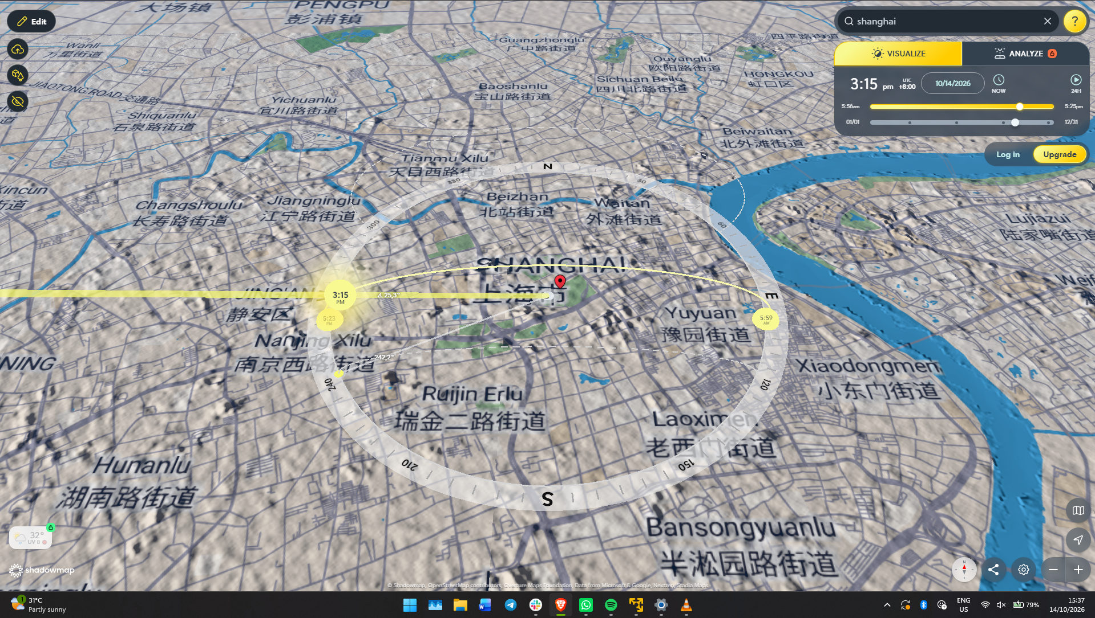
New Home | 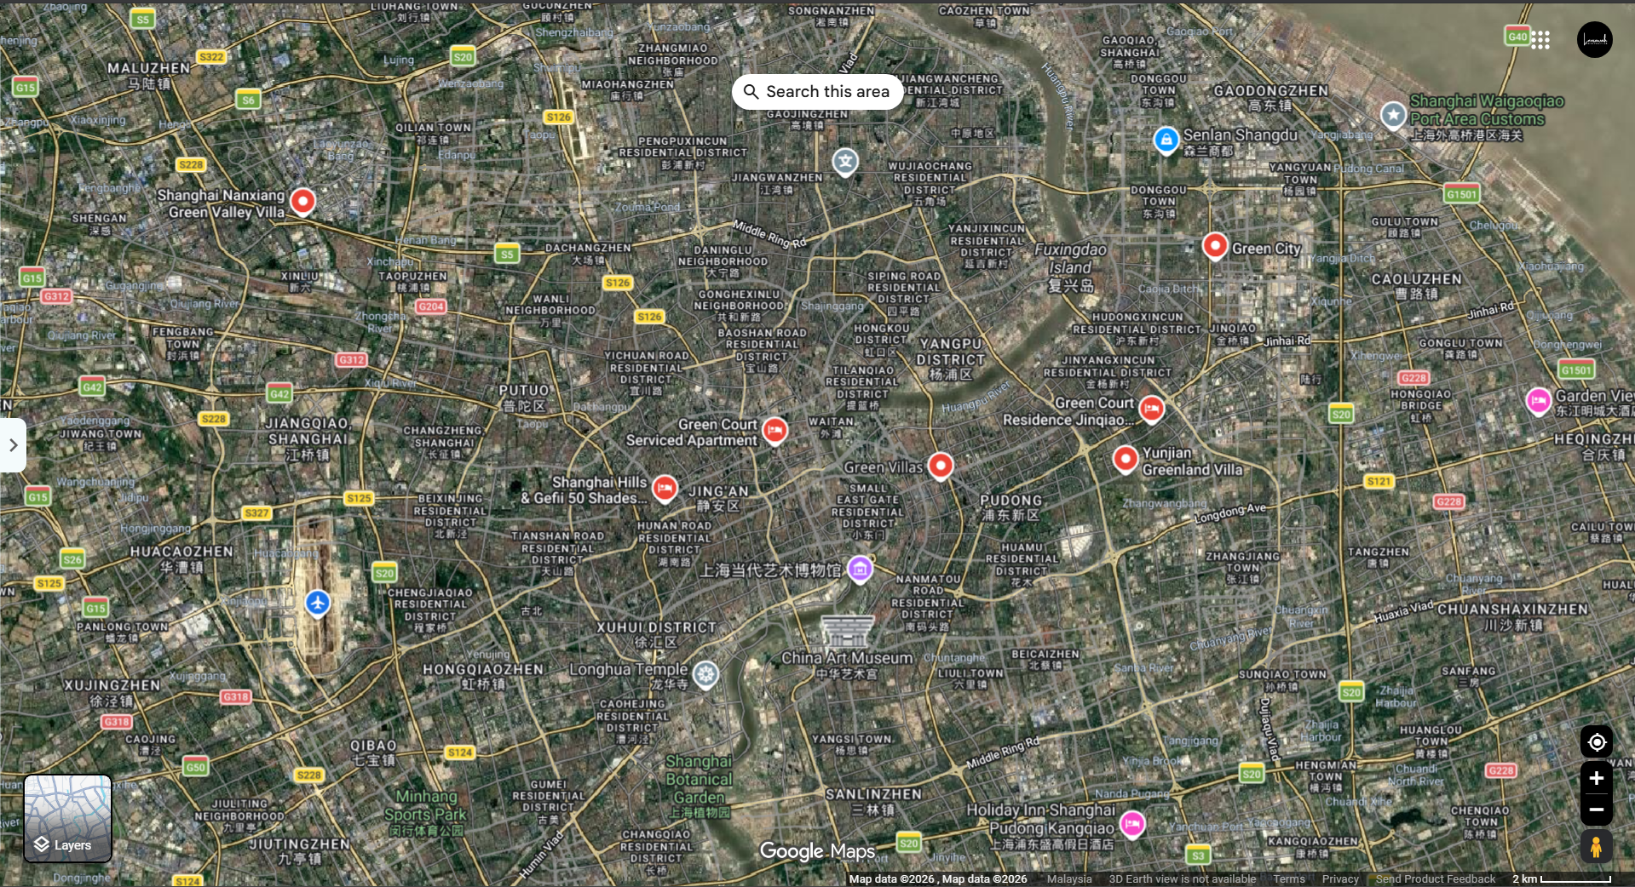  Green Hills, Shanghai, China

